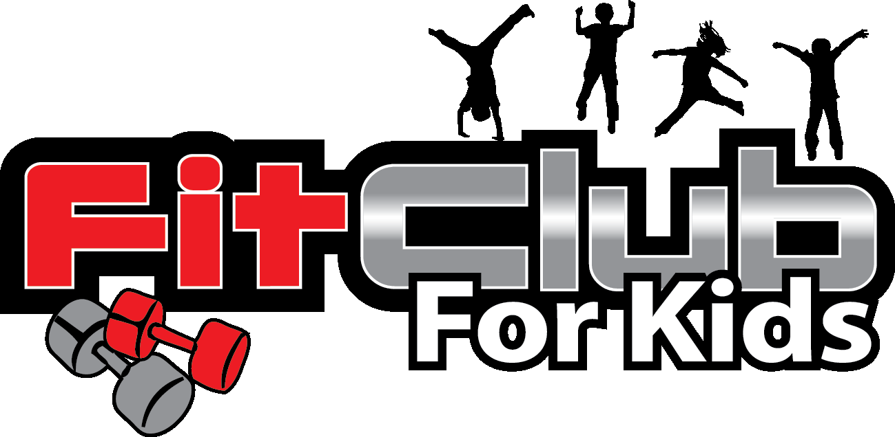

Fit Club for Kids is a 9-week fitness class that meets once per week. Activities center on cardiovascular endurance, muscular strength, flexibility, balance, coordination, and nutrition. Enrollment is limited. All participants receive a Fit Club t-shirt. A portion of the registration fee benefits the ESE Foundation. Send in completed registration form along with $216 check to the ESE Foundation Box by Tuesday, August 31st. Make check payable to: Fit Club for Kids, LLC. or Venmo @ Amy-Whatley.

Session  (circle one) | Grades K, 1, & 2 Tue Afternoons 9 weeks Sept 14 - Dec 7 2:30 – 3:40pm  Grades 2, 3, 4 & 5 Thu Afternoons 9 weeks Sept 16 - Dec 2 2:30 – 3:40pm  No Fit Club on conference week or on early-release days
Student Name
Teacher / Grade  (circle one) | _________________________________ / K 1 2 3 4 5
Parent #1
Name
Phone # / Email | __ __ __ - __ __ __- __ __ __ __ / ______________________@_____________
Parent #2
Name
Phone # / Email | __ __ __ - __ __ __ - __ __ __ __ / ______________________@______________
T-shirt Size  (circle one) | YS / YM / YL / YXL / AS / Other ___________
Food Allergies
Medical Conditions
ASP or Carpool  (circle one) | Will your child check-in to ASP or be picked up in CARPOOL following Fit Club?

If FCFK is unable to provide the nine classes as set forth above because of an unscheduled closure of the school (i.e., snow day) no refund will be offered for the unfulfilled classes. HOWEVER, if FCFK is unable to provide the nine classes for any other reason (including school closure due to Covid), we will offer a discount for a future session of Fit Club, prorated for the number of classes not fulfilled.

Per East Side Administration, all participants in after-school enrichment programs are required to register for the After School Program (ASP) even if you do not plan to use ASP on a regular basis. Please register for ASP if you have not already done so.

I hereby release my child into the care of the Fit Club staff during one of the above-listed times. I understand that he/she will be participating in fitness activities that involve some inherent risk. I release Fit Club for Kids, Cobb County School District, East Side Elementary, and East Side Elementary Foundation from liability related to such activities and risk. I also agree that my child may be included in pictures that are posted from time to time to Fit Club’s Facebook page or website.

Parent Signature: ________________________________________________________ Date: ___________________

Amy Whatley
Fit Club for Kids, LLC
EIN: 46-2019933
fitclubforkids@gmail.com

