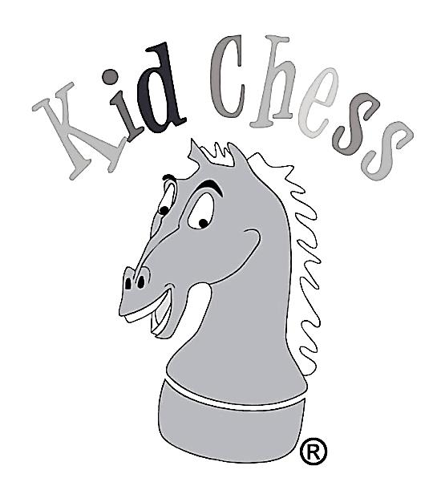
Chess Club Information
Fall Dates (Club meets every Tuesday or Thursday that school is in session).
- Tuesday club: January 22, 2019 – May 7, 2019 (Trophy Day – parents invited).
- Thursday club: January 24, 2019 – May 9, 2019 (Trophy Day – parents invited).

Fall Tuition & Times
- $319 for the 1st hour (2:30-3:30PM)
- $239 for the 2nd hour (3:40-4:40PM)
- $439 for the 1st & 2nd hours combined (2:30-4:40PM).

- Lesson presentation is differentiated in each of the two hours.
- Kindergarteners may only enroll in the 2nd hour.
- 15% of all tuition funds are contributed back to the Foundation.
- Students must be registered with East Side ASP in order to participate in the Kid Chess program
- Classes will not meet on early release days.

How do I register?
You can register through our website at www.kidchess.com, by phone (770.575.5802), or by completing the form below.
Please send the form to Kid Chess. Do not drop off the form at the school.

East Side Elementary Tuesday or Thursday Chess Club
Registration Form - Spring 2019

Student Grade Teacher
Parent(s) Home #
Cell #(s) Work #(s)
E-mail Address (es)
(E-mail is our primary form of communication with parents. We will NEVER sell or distribute your e-mail address.)
Emergency Contact Emergency #
Please circle the day you would like your child to attend: (Select One) Tuesday Thursday

Please circle the hour(s) you would like your child to attend: (Select One)

1st Hour ($319) 2nd Hour ($239) Both 1st & 2nd hours ($439)
1st Hour Annual ($618) 2nd Hour Annual ($428) 1st-2nd Hrs Combo Annual ($858)

After chess class, my child: (Select One)
_____ Will attend the after-school program _____ Will be picked up in car pool**

**Please be advised that car pool students will be admitted to ASP & charged any required ASP fees if not picked up within 10 minutes after class ends.
**2nd hour students that came from ASP, must return to ASP.

2nd hour class only – Before chess, my child: (Select One)
____Will attend the after-school program. ____Will be at home & be brought back to chess by a parent/guardian.
Payment Method:
Circle one: Visa MasterCard AMEX OR Check Amount $
CC Number: Expiration date:
Name on Card: Verification #:
Please fill out and send to:
Kid Chess, 1855 Piedmont Road, Suite 100, Website: www.kidchess.com
Marietta, GA 30066 Email: info@kidchess.com
Please make checks payable to “Kid Chess”. Phone: 770.575.5802

